6/23/2017

Laporan UAS Pemrograman Web

Media Pembelajaran dengan HTML, CSS, dan JavaScript untuk Latihan Berhitung Sekolah Dasar

**Dosen Pengampu :**

Nurkhamid, Ph.D

**Disusun Oleh :**

Eko Setyo Purwanto

16520244002

Pendidikan Teknik Informatika

Jurusan Pendidikan Teknik Elektronika dan Informatika

Fakultas Teknik Universitas Negeri Yogyakarta

2017

1. Daftar Isi

COVER

Daftar Isi 1

Latar Belakang 2

Deskripsi 2

Tujuan Aplikasi 2

Alat dan Bahan 2

Langkah Kerja 3

Source Code 6

Output / Hasil Program 27

Daftar Pustaka 28

1. Latar Belakang

Di era modern ini, banyak sekali perkembangan teknologi, mulai dari yang bersifat memanfaatkan SDA hingga memanfaatkan SDM yang ada, sebagai contoh : Aplikasi Go-Jek, Traveloka, Lazada, BeSmart, E-Learning, E-Banking, Dll. Aplikasi tersebut banyak sekali membuat manfaat bagi kehidupan kita sekarang ini, mulai dari membuat orang lain memiliki pekerjaan, hingga memudahkan orang yang membutuhkan jasa – jasa tersebut pada waktu tertentu.

1. Deskripsi

Program ini bertujuan untuk memudahkan adik – adik Sekolah Dasar untuk belajar berhitung dengan tampilan yang menarik dan edukatif

1. Tujuan Aplikasi

Aplikasi ini berbentuk GUI yang mana diharapkan dapat memudahkan adik – adik dalam mengerjakan soal. Walaupun tanpa gambar, tapi program ini memiliki tampilan yang menarik serta friendly untuk adik – adik Sekolah Dasar.

1. Alat dan Bahan
2. Laptop
3. Adobe Dreamweaver / Sublime Text
4. Langkah Kerja
5. 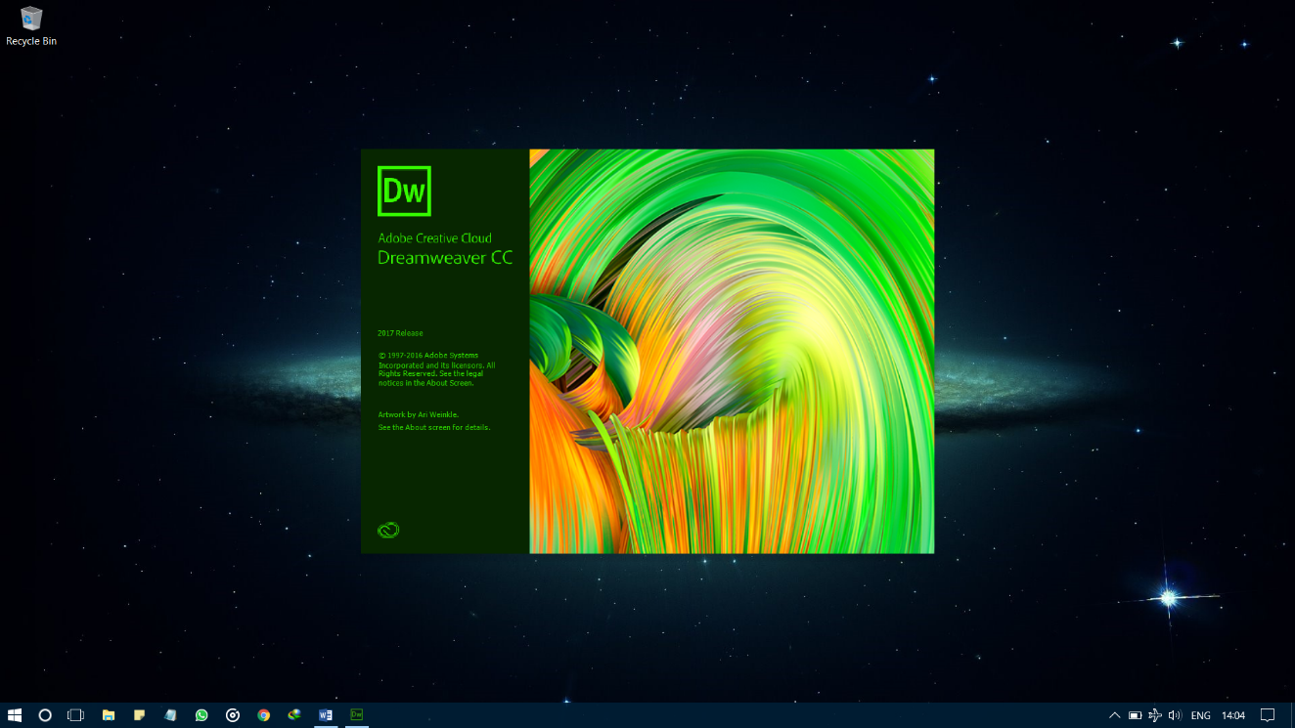Buka Aplikasi Programming yang akan digunakan, disini kami menggunakan Aplikasi Adobe Dreamweaver.
6. 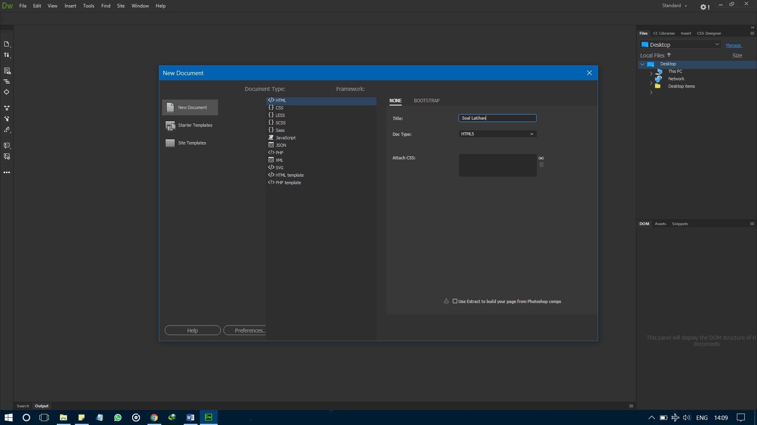Selanjutnya buat Project Baru dengan cara klik File > New Document > HTML > HTML5 dengan tittle Soal Latihan.
7. 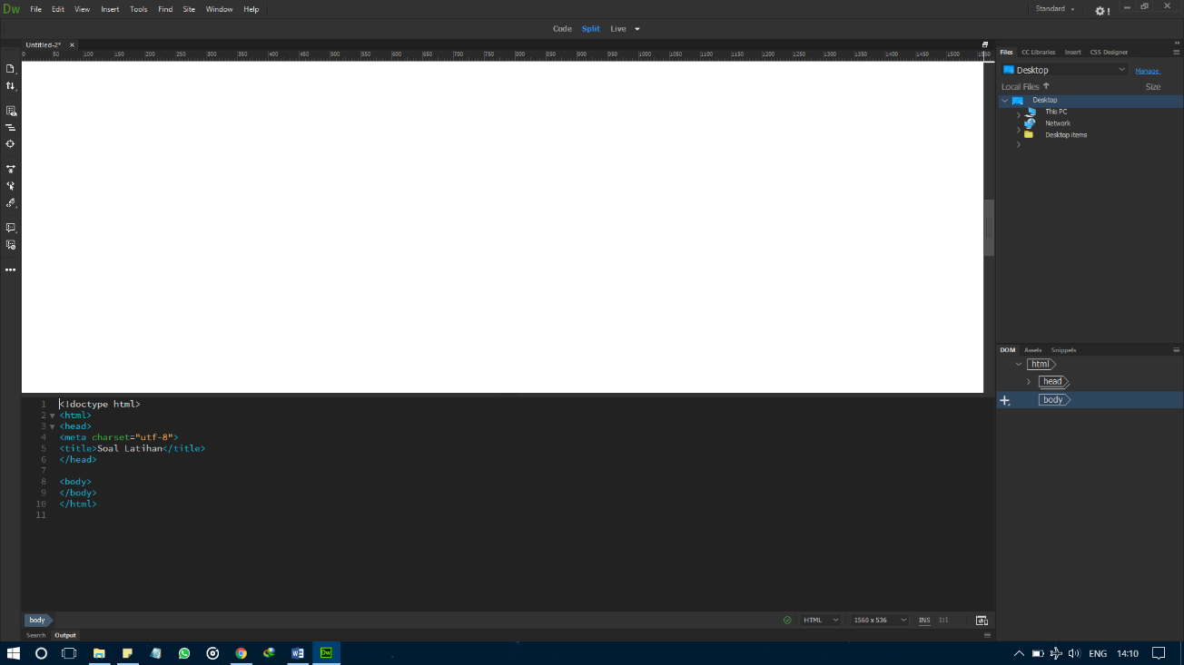Tampilan awal index.
8. 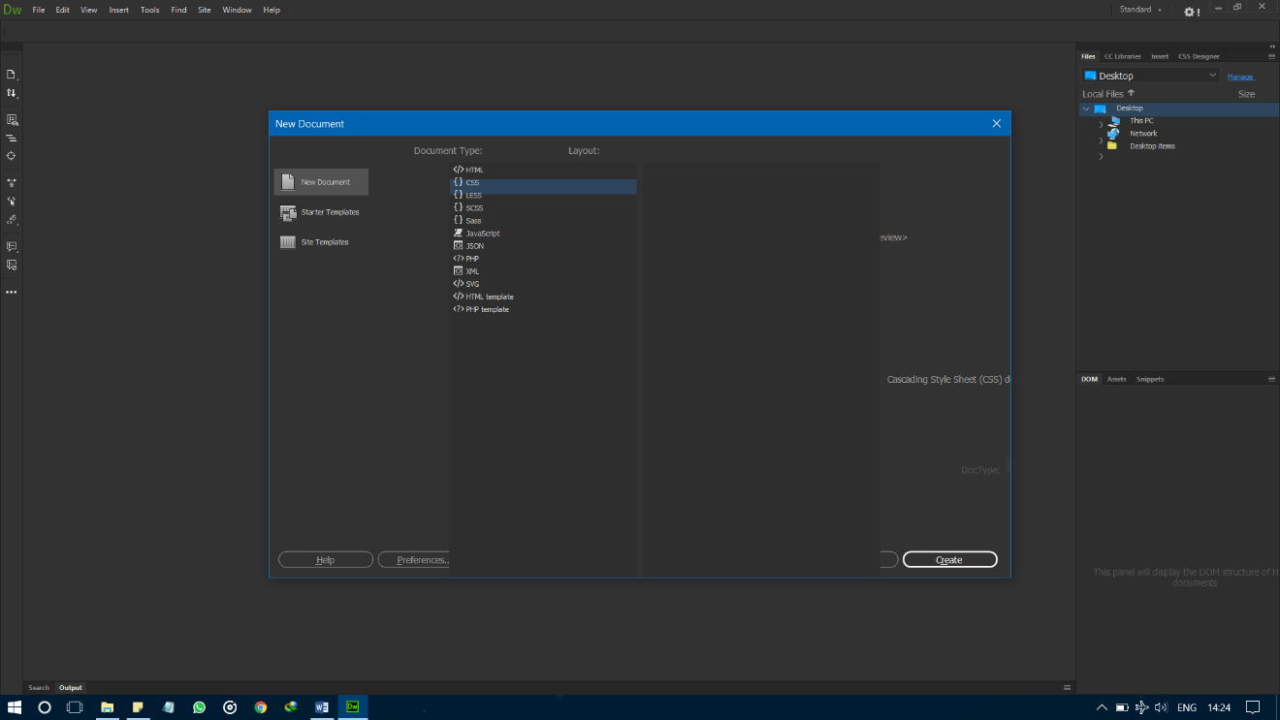Selanjutnya buat Project CSS dengan cara klik File > New Document > CSS.
9. 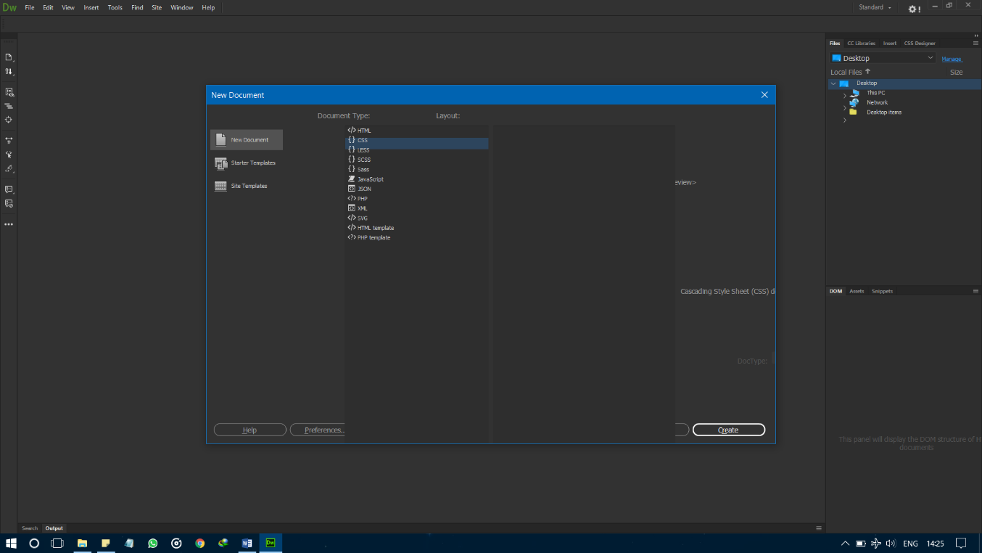Selanjutnya buat Project JavaScript dengan cara klik File > New Document > JavaScript.
10. Source Code
11. Index.html

<!DOCTYPE html>

<html >

<head>

<meta charset="UTF-8">

<title>Soal Latihan</title>

<meta charset="utf-8">

<meta http-equiv="x-ua-compatible" content="ie=edge">

<meta name="viewport" content="width=device-width, initial-scale=1.0">

<link rel="stylesheet" href="https://cdn.jsdelivr.net/foundation/6.2.4-rc2/foundation.min.css">

<link rel="stylesheet" href="https://cdnjs.cloudflare.com/ajax/libs/normalize/5.0.0/normalize.min.css">

<link rel="stylesheet prefetch" href="https://cdn.jsdelivr.net/foundation/6.2.4-rc2/foundation.min.css">

<link rel="stylesheet prefetch" href="https://cdn.jsdelivr.net/foundation-icons/3.0/foundation-icons.min.css">

<link rel="stylesheet" href="css/style.css">

</head>

<body>

<body>

<body>

<noscript>

<p>Page Iki Mesti Ono JavaScript-enabled browser.</p>

</noscript>

<!-- TITLE BAR Nduwur -->

<div data-sticky-container>

<div class="small-12 sticky" data-sticky data-sticky-on="small" >

<div class="title-bar" data-responsive-toggle="main-menu" data-hide-for="medium">

<button class="menu-icon" type="button" data-toggle></button>

<div class="title-bar-title">Soal Latihan Untuk Sekolah Dasar</div>

</div>

<div class="top-bar" id="main-menu">

<div id="topBarLeft" class="top-bar-left">

<ul class=" menu hide-for-small-only" data-dropdown-menu>

<li class="menu-text">Soal Latihan Untuk Sekolah Dasar</li>

</ul>

</div>

<div id="topBarRight" class="top-bar-right">

<ul class="menu accordion-menu vertical medium-horizontal" data-responsive-menu="accordion medium-dropdown">

<li>

<a id="myScores" href="#" data-toggle="myScoreDisplay">Perlihatkan Hasil Kerja Saya</a></li>

<ul>

<li>

</li>

</ul>

</ul>

</div>

</div>

<!-- Tampilane Score -->

<div id="myScoreDisplay" class="row " data-toggler=".slideInMyScore">

<div id="showUserScores" class=""></div>

</div>

</div>

</div>

<!-- TITLE BAR Rampung -->

<!-- Iki Soal -->

<div class="row">

<div id ="quizContainer" class="callout default-primary-color medium-8 small-12 columns">

<!-- Pesan Karo Area Mulai -->

<div class="row">

<div id="quizNotify" class="message small-11 columns">

<div class="">

<h4 id="message"></h4>

</div>

<div class="quizButton large-2">

<input type="button" id="startButton" class="buttons" value="Mulai Latihan!" />

</div>

<div id="results" class="results"></div>

<div class="quizButtons ">

</div>

</div>

</div>

<!-- Area Jawaban Soal -->

<div class="row">

<div id="formContainer" class="main ">

<form id="form1" class="answer" action="" name="form1">

</form>

</div>

</div>

<!-- Area Tombol Soal -->

<div class="row">

<div id="quizButtons" class="quizButtons large-10 medium-10 columns">

<div id="previous" class="quizButton large-2">

<input type="button" id="prevButton" class="buttons" value="Kembali!" />

</div>

<div id="next" class="quizButton large-2">

<input type="button" id="nextButton" class="buttons" value="Lanjut" />

</div>

<div id="score" class="quizButton large-2">

<input type="button" id="scoreButton" class="buttons" value="Lihat Nilai" />

</div>

</div>

</div>

<!-- Peringatan Bos -->

<div class="row large-10 medium-10 columns">

<!-- warning in case question is not answered -->

<div class="warning">

<small id="warning" class=""></small>

</div>

</div>

<!-- Progress e -->

<div id="progressBar" class="">

<div class="progress" role="progressbar" tabindex="0" aria-valuenow="0" aria-valuemin="0" aria-valuetext="0 out of quizLength" aria-valuemax="3">

<span id="progressMeter" class="progress-meter" style="width: 25%">

<p id="progressMeterText" class="progress-meter-text"> </p>

</span>

</div>

</div>

</div>

</div>

</body>

<!-- Soal Rampung -->

<script src="https://code.jquery.com/jquery-1.12.0.min.js"></script>

<script src="https://cdn.jsdelivr.net/foundation/6.2.4-rc2/foundation.min.js"></script>

</body>

<script src="https://cdnjs.cloudflare.com/ajax/libs/jquery/3.1.0/jquery.min.js"></script>

<script src="https://cdnjs.cloudflare.com/ajax/libs/modernizr/2.8.3/modernizr.min.js"></script>

<script src="https://cdn.jsdelivr.net/foundation/6.2.4-rc2/foundation.min.js"></script>

<script src="js/index.js"></script>

</body>

</html>

1. Style.css

.title-bar {

background: #689F38;

padding: 0.9rem;

margin-top: -1rem;

}

.top-bar {

background: #689F38;

color: #ffffff;

margin-top: -1rem;

}

.top-bar ul {

background: #689F38;

}

.top-bar-right ul li {

list-style-type: none;

text-align: right;

padding: 0.2rem;

border-top: 0.1rem solid #8BC34A;

}

.top-bar-right ul li:first-child {

border-top: none;

}

.top-bar ul li a {

color: #ffffff;

transition: color 0.5s ease;

}

.top-bar ul li a:hover {

color: #7c4dff;

}

li.is-submenu-item.is-accordion-submenu-item {

background-color: #689F38;

}

.is-accordion-submenu-parent > a::after {

border-color: #ffffff transparent transparent;

right: 0;

}

/* umum */

body {

background:url(../minions.jpg);

color: #212121;

}

.message {

margin: 1.5rem;

padding: 1.5rem;

background-color: #689F38;

color: #ffffff;

}

#message {

margin: 0 0 1.5rem 0;

color: #ffffff;

border-radius: 0.5rem;

}

#notify {

color: #212121;

}

.results {

margin: 1rem 0;

color: #000000;

}

.red {

color: #f5543a;

}

.green {

color: #b4f36b;

}

.success {

color: #3adb76;

}

.warning {

color: #ffae00;

}

/*.div jawabane { */

.radio {

}

.radio input[type="radio"] {

position: absolute;

opacity: 0;

}

.radio input[type="radio"] + .radio-label:before {

content: '';

background: #f4f4f4;

border-radius: 100%;

border: 1px solid #b4b4b4;

display: inline-block;

width: 1.6em;

height: 1.6em;

position: relative;

top: -0.2em;

left: -1rem;

margin-right: 1em;

vertical-align: top;

cursor: pointer;

text-align: center;

transition: all 250ms ease;

}

.radio input[type="radio"]:checked + .radio-label:before {

background-color: #7c4dff;

box-shadow: inset 0 0 0 4px #f4f4f4;

}

.radio input[type="radio"]:focus + .radio-label:before {

outline: none;

border-color: #7c4dff;

}

.radio input[type="radio"]:disabled + .radio-label:before {

box-shadow: inset 0 0 0 4px #f4f4f4;

border-color: darken(#f4f4f4, 25%);

border-color: #b4b4b4;

}

.radio input[type="radio"]:empty + .radio-label:before {

margin-right: 0;

}

input[type="text"], input[type="password"] {

margin-bottom: 0.1rem;

}

input[type="button"], input[type="submit"] {

border: none;

border-radius: 5rem;

background-color: #7c4dff;

padding: 1.0rem 1.0rem;

margin-right: 1rem;

transition: background-color 0.5s ease;

}

input[type="button"]:focus, input[type="submit"]:focus {

outline:0;

}

input[type="button"]:hover, input[type="submit"]:hover {

color: #000000;

background-color: #FFC107;

}

input#deleteBtn {

float: right;

background-color: #FFC107;

margin-top: 2rem;

}

input#deleteBtn:hover {

color: #ffffff;

background-color: #7c4dff;

}

label {

text-align: left;

font-weight: bold;

}

.buttons {

padding: 1rem;

font-size: smaller;

font-weight: bold;

margin: 0.5rem 0 2rem 0;

}

.show {

display: visible;

}

.hide {

display: none;

}

/* login */

.loginMain {

margin-top: 1.5rem;

padding: 0.5rem;

}

.login, .submit, .warning {

margin: 0rem 1.5rem 1.5rem 1.5rem;

}

.warning {

font-weight: bold;

color: #D32F2F;

margin: 0.5rem 0 1rem 0

}

.submit {

margin: 1rem 1.5rem;

color: #ffffff;

}

.notify {

margin: 1rem 1.5rem;

font-weight: bold;

color: #D32F2F;

}

/* quiz */

.callout {

display: inline-block;

background-color: #DCEDC8;

border: 1rem solid #FFC107;

border-radius: 1.8rem;

margin: 2.5rem 0;

}

.main, .quizButtons {

margin: 1rem 2rem;

}

.main h3 {

margin: 1.5rem 0;;

}

.main div {

margin: 0 0 0.7rem 0.5rem;

}

.answer p{

margin-bottom: 0.1rem;

}

.quizButtons {

color: #ffffff;

padding: 0;

}

.quizButton {

display: inline-block;

}

#scoreButton {

color: #000000;

background-color: #FFC107;

}

#scoreButton:hover {

color: #FFFFFF;

background-color: #7c4dff;

}

.results {

color: white;

margin-top: 1.5rem;

}

/* Nampilke Score */

#myScoreDisplay {

z-index: 10;

position: absolute;

right: -20rem;

top: 5rem;

-webkit-transform: translate(0rem, 0);

transform: translate(0rem, 0);

transition: transform 0.3s ease;

}

#myScoreDisplay.slideInMyScore {

transform: translate(-20rem,0);

webkit-transform: translate(-20rem,0);

}

#showUserScores {

margin: 1rem;

padding: 1rem 1.5rem;

color: #ffffff;

background: #7c4dff;

border-radius: 2rem;

}

.emphasis {

padding: 0.5rem;

background-color: #FFC107;

text-transform: uppercase;;

}

p.emphasis {

color: #7c4dff;

margin-bottom: 0;

font-weight: bold;

}

.progress {

background-color: #ffffff;

height: 1.8rem;

border-radius: 3rem;

padding: 0 0.5rem;

}

.progress-meter {

background-color: #689F38;

border-radius: 3rem;

}

.progress-meter-text {

color: #000000;

}

/* ==========================================================================

Kelas Bantuan

========================================================================== */

.hidden {

display: none !important;

}

.visuallyhidden {

border: 0;

clip: rect(0 0 0 0);

height: 1px;

margin: -1px;

overflow: hidden;

padding: 0;

position: absolute;

width: 1px;

}

.visuallyhidden.focusable:active,

.visuallyhidden.focusable:focus {

clip: auto;

height: auto;

margin: 0;

overflow: visible;

position: static;

width: auto;

}

.invisible {

visibility: hidden;

}

.clearfix:before,

.clearfix:after {

content: " "; /* 1 */

display: table; /* 2 */

}

.clearfix:after {

clear: both;

}

@media only screen and (min-width: 35em) {

.top-bar-left ul li {

font-size: 1.5rem;

}

}

@media print,

(-webkit-min-device-pixel-ratio: 1.25),

(min-resolution: 1.25dppx),

(min-resolution: 120dpi) {

}

@media print {

*,

*:before,

*:after,

*:first-letter,

*:first-line {

background: transparent !important;

color: #000 !important;

box-shadow: none !important;

text-shadow: none !important;

}

a,

a:visited {

text-decoration: underline;

}

a[href]:after {

content: " (" attr(href) ")";

}

abbr[title]:after {

content: " (" attr(title) ")";

}

a[href^="#"]:after,

a[href^="javascript:"]:after {

content: "";

}

pre,

blockquote {

border: 1px solid #999;

page-break-inside: avoid;

}

thead {

display: table-header-group;

}

tr,

img {

page-break-inside: avoid;

}

img {

max-width: 100% !important;

}

p,

h2,

h3 {

orphans: 3;

widows: 3;

}

h2,

h3 {

page-break-after: avoid;

}

}

1. Index.js

$(document).foundation();

var topBarLeft = document.getElementById("topBarLeft"),

topBarRight = document.getElementById("topBarRight"),

total = document.getElementById("total");

var welcome = document.getElementById("welcome");

var message = document.getElementById("message");

var results = document.getElementById("results");

var startButton = document.getElementById("startButton"),

quizContainer = document.getElementById("quizContainer"),

quizNotify = document.getElementById("quizNotify"),

quizLength = 0,

choices = [] ,

index = 0,

formContainer = document.getElementById("formContainer"),

form = document.form1,

warning = document.getElementById("warning");

var allQuestions = [

{

"question":"Berapa hasil dari 8 + 7?",

"choices":["15","16","17","12"],

"correctAnswer":0

},

{

"question":"Berapa hasil dari 9 + 8?",

"choices":["15","19","17","18"],

"correctAnswer":2

},

{

"question":"Berapa hasil dari 7 + 5?",

"choices":["14","12","16","17"],

"correctAnswer":1

},

{

"question":"Berapa hasil dari 18 - 12?",

"choices":["8","7","6","5"],

"correctAnswer":2

},

{

"question":"Berapa hasil dari 15 - 5?",

"choices":["5","10","16","17"],

"correctAnswer":1

},

{

"question":"Berapa hasil dari 14 - 8?",

"choices":["6","8","16","24"],

"correctAnswer":0

},

{

"question":"Berapa hasil dari 7 * 5?",

"choices":["14","35","23","24"],

"correctAnswer":1

},

{

"question":"Berapa hasil dari 25 * 5?",

"choices":["225","135","125","175"],

"correctAnswer":2

},

{

"question":"Berapa hasil dari 36 * 5?",

"choices":["80","280","340","180"],

"correctAnswer":3

},

{

"question":"Berapa hasil dari 6 * 4?",

"choices":["26","25","24","23"],

"correctAnswer":2

}

];

var storedAnswers = [];

var storedScores = [];

var quizButtons = document.getElementById("quizButtons"),

prevButton = document.getElementById("prevButton"),

next = document.getElementById("next"),

nextButton = document.getElementById("nextButton"),

scoreButton = document.getElementById("scoreButton");

var scoreDisplay = document.getElementById("scoreDisplay"),

myScores = document.getElementById("myScores");

var progressBar = document.getElementById("progressBar");

var progressMeter = document.getElementById("progressMeter");

var progressMeterText = document.getElementById("progressMeterText");

//quizButtons.classList.add("hide");

//scoreDisplay.setAttribute("style", "display:visible");

startButton.addEventListener("click", startQuiz);

myScores.addEventListener("click", showUserScores);

prevButton.addEventListener("click", previousQuestion);

nextButton.addEventListener("click", nextQuestion);

scoreButton.addEventListener("click", showScore);

//shows welcome message and startbutton

quizContainer.classList.remove("hide");

// three parts of quizContainer:

quizNotify.classList.remove("hide");

formContainer.classList.add("hide");

quizButtons.classList.add("hide");

progressBar.classList.add("hide");

progressBar.setAttribute("aria-valuemax", quizLength);

message.innerHTML = "Sugeng Rawuh! <br/>Selamat Datang di Soal Latihan! <br />Siap Dek? <br/><br/> | Bismillah ben lancar dek |";

startButton.setAttribute("style", "display:visible");

function startQuiz() {

index = 0;

quizNotify.classList.add("hide");

quizButtons.classList.remove("hide");

progressBar.classList.remove("hide");

if (storedAnswers.length !== 0) {

storedAnswers.length = 0;

}

quizLength = allQuestions.length;

showProgress(index);

showQuestion();

}

function showQuestion() {

showQuizButtons();

if (index === quizLength) {

return;

}

// display of question at given index:

formContainer.classList.remove("hide");

form.innerHTML = "";

var quizItem = allQuestions[index];

var q = document.createElement("h3");

var text = document.createTextNode(quizItem.question);

var storedAnswer = storedAnswers[index];

q.appendChild(text);

form.appendChild(q);

// display of choices, belonging to the questions at given index:

choices = allQuestions[index].choices;

for (var i = 0; i < choices.length; i++) {

var div = document.createElement("div");

div.classList.add("radio");

var input = document.createElement("input");

input.setAttribute("id", i);

input.setAttribute("type", "radio");

input.setAttribute("name", "radio");

if (i === quizItem.correctAnswer) {

input.setAttribute("value", "1");

} else {

input.setAttribute("value", "0");

}

//if question has been answered already

if (storedAnswer) {

var id = storedAnswer.id;

if (i === id) {

// if question is already answered, id has a value

input.setAttribute("checked", "checked");

}

}

//if radiobutton is clicked, the chosen answer is stored in array storedAnswers

input.addEventListener("click", storeAnswer);

var label = document.createElement("label");

label.setAttribute("class", "radio-label");

label.setAttribute("for", i);

var choice = document.createTextNode(choices[i]);

label.appendChild(choice);

div.appendChild(input);

div.appendChild(label);

form.appendChild(div);

}

}

function showProgress(index) {

///update progress bar

var increment = Math.ceil((index) / (quizLength) * 100);

// var increment = index;

progressMeter.style.width = (increment) + '%';

progressMeterText.innerHTML = (index) + ' dari ' + quizLength;

if (index === 0) {

progressMeter.style.width = (25) + '%';

progressMeter.style.background = "#ffffff";

//progressMeterText.style.color = "000000";

}

else {

progressMeter.style.background = "#689F38";

}

}

function storeAnswer(e) {

var element = e.target;

var answer = {

id: element.id,

value: element.value

};

storedAnswers[index] = answer;

}

function showQuizButtons() {

if(index === 0) {

//there is no previous question when first question is shown

prevButton.classList.add("hide");

}

if (index > 0) {

prevButton.classList.remove("hide");

}

if(index === quizLength) {

//only if last question is shown user can see the score

scoreButton.classList.remove("hide");

nextButton.classList.add("hide");

//prevButton still visible so user can go back and change answers

var h2 = document.createElement("h2");

h2.innerHTML = "Rampung! Pingin ndelok nilaine dek?";

form.appendChild(h2);

}

else {

nextButton.classList.remove("hide");

scoreButton.classList.add("hide");

}

}

// http://jsfiddle.net/hvG7k/

function previousQuestion() {

//shows previous question, with chosen answer checked

index--;

warning.innerHTML = "";

form.innerHTML = "";

$("#form1").fadeOut(0, function() {

var show = showQuestion();

$(this).attr('innerHTML', 'show').fadeIn(300);

});

}

function nextQuestion() {

//shows next question only if current question has been answered

if (storedAnswers[index] == null) {

warning.innerHTML = "Silahkan Pilih Salah Satu Jawaban Yang Anda Anggap Benar!";

return;

}

index++;

warning.innerHTML = "";

form.innerHTML = "";

$("#form1").fadeOut(0, function() {

var show = showQuestion();

$(this).attr('innerHTML', 'show').fadeIn(300);

});

showProgress(index);

}

function showScore() {

form.innerHTML = "";

prevButton.classList.add("hide");

scoreButton.classList.add("hide");

progressBar.classList.add("hide");

quizNotify.classList.remove("hide");

startButton.classList.remove("hide");

var totalScore = 0;

var output = "";

var questionResult = "NA";

for (var i = 0; i < storedAnswers.length; i++) {

var score = parseInt(storedAnswers[i].value);

if (score === 1) {

questionResult = '<i class="fi-check green"></i>';

}

else {

questionResult = '<i class="fi-x red"></i>';

}

output = output + '<p>Soal ' + (i + 1) + ': ' + questionResult + '</p> ';

totalScore += score;

}

if (totalScore === allQuestions.length) {

message.innerHTML = "Hebat! Nilaimu " + totalScore + " seko " + allQuestions.length + " dek!<br />Selamat!";

}

else if (totalScore <= 7) {

message.innerHTML = "Nilaimu kurang dek!<br/> Mesti banyak latihan, nilaimu " + totalScore + " seko " + allQuestions.length + " dek!<br />Ayo sinau meneh!";

}

else {

message.innerHTML = "Selamat! Nilaimu apik dek, nilaimu " + totalScore + " seko " + allQuestions.length + " dek!<br />Gelem latihan meneh?";

}

results.innerHTML = output;

// Total Score e

storedScores.push(totalScore);

updateScore(totalScore);

}

//Ndelok Total Score

function showUserScores(e) {

e.preventDefault();

var showUserScores = document.getElementById("showUserScores");

while (showUserScores.firstChild) {

showUserScores.removeChild(showUserScores.firstChild);

}

if (myScores.innerHTML === "Show my scores") {

myScores.innerHTML = "Hide my scores";

}

else if (myScores.innerHTML === "Hide my scores") {

myScores.innerHTML = "Show my scores";

}

var userScores = storedScores;

var h4 = document.createElement("h4");

h4.innerHTML = "Nilai Anda Sebelumnya";

var string = "";

for (var i = 0; i < storedScores.length; i++) {

string += storedScores[i] + "<br/>";

}

var p = document.createElement("p");

p.setAttribute("id", "scores");

if (userScores.length === 0) {

string = "Koe durung nggarap soal le!";

}

p.classList.add("emphasis");

p.innerHTML = string;

showUserScores.appendChild(h4);

showUserScores.appendChild(p);

}

function updateScore(score) {

var showUserScores = document.getElementById("showUserScores");

var scores = document.getElementById("scores");

if (myScoreDisplay.classList.contains("slideInMyScore")) {

scores.innerHTML = "";

var string = "";

for (var i = 0; i < storedScores.length; i++) {

string += storedScores[i] + "<br/>";

}

scores.innerHTML = string;

}

}

1. 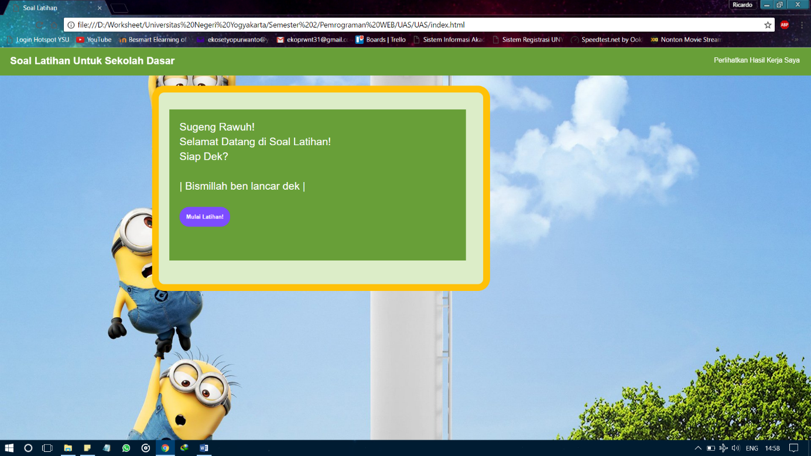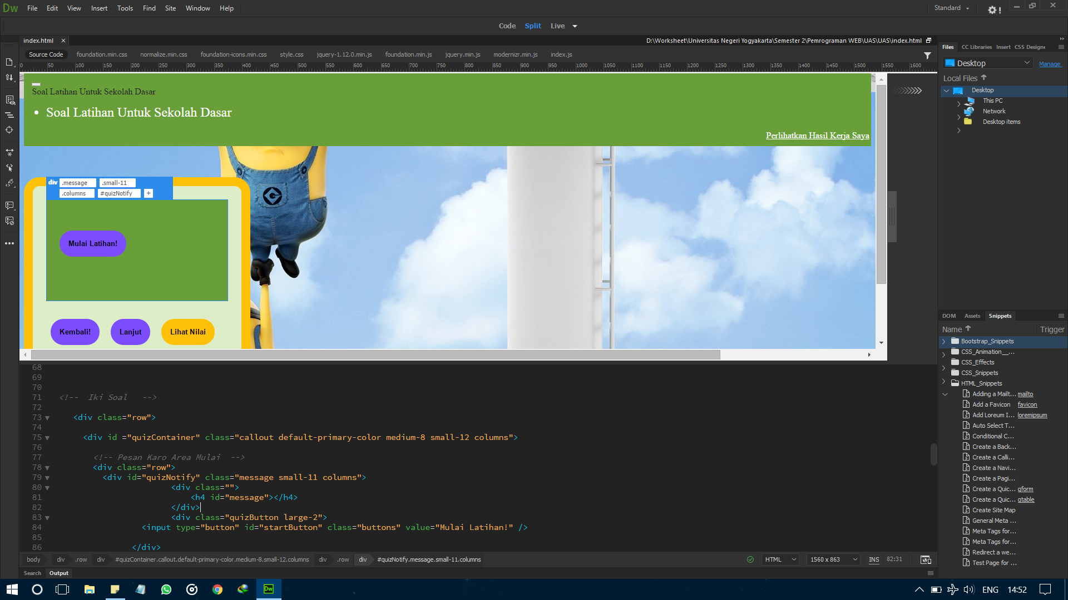Output / Hasil Program

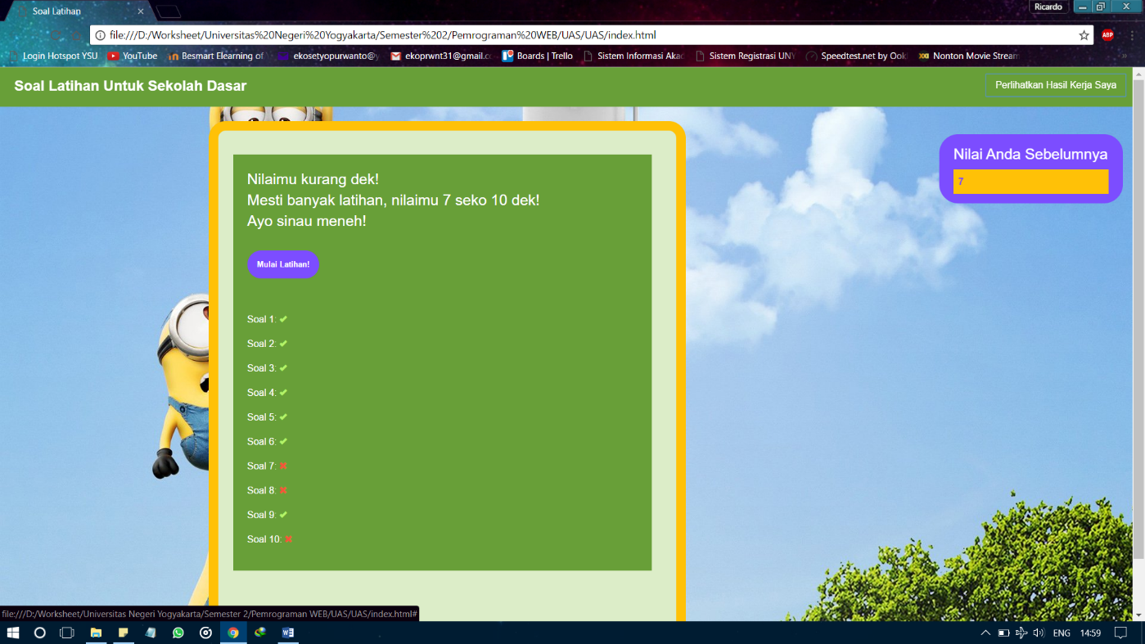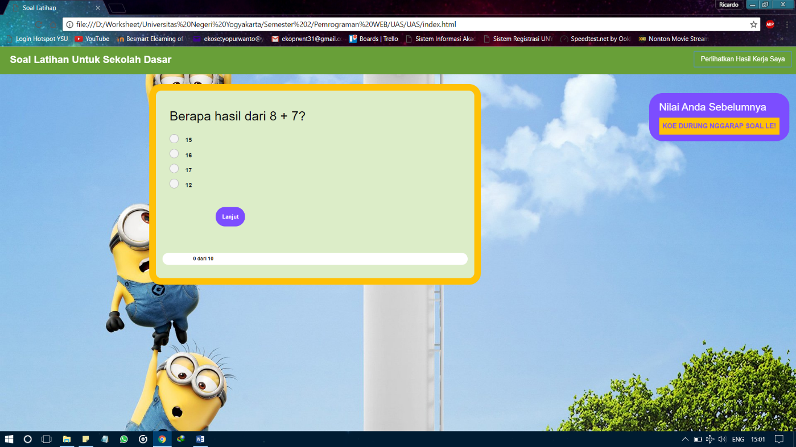

1. Daftar Pustaka

<https://www.youtube.com>/

<https://www.google.co.id/>

<https://stackoverflow.com/>